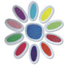Daisy Petal Set
- $8.50

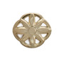Girl Scout Daisy Membership Pin
- $2.00
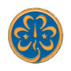World Trefoil Pin
- $2.50
Material: Regular
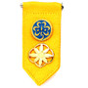Girl Scout Daisy Insignia Tab
- $3.00

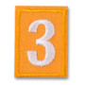Made In The USA - Girl Scout Daisy Troop Numeral
- $1.75
Troop Number 18XXX
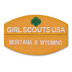Made In The USA - Girl Scout Daisy Council Identification Set
- $5.50
Select Council Name: Minnesota and Wisconsin River Valleys
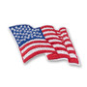Made In The USA - Wavy American Flag Patch
- $2.25

SELECT ONE: EITHER THE TUNIC OR THE VEST:
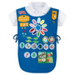Official Daisy Tunic
- $16.50
Size: Select Size
•
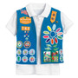Official Daisy Vest
- $18.50
Size: Select Size

